Regression.US_FullFlow_15-Nov-2017 07-30-05 PM.png

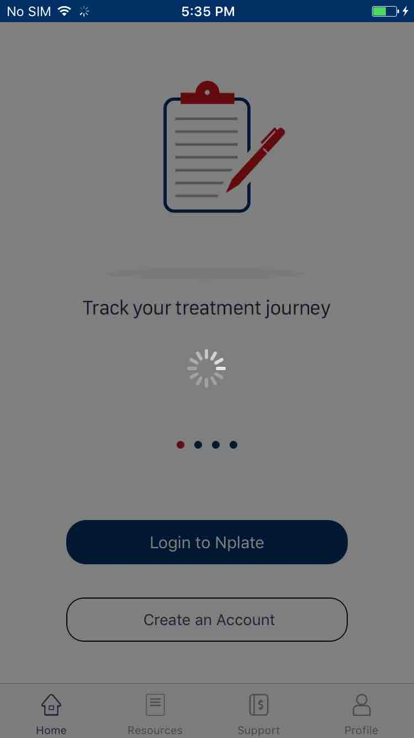

Regression.US_FullFlow_15-Nov-2017 07-30-10 PM.png

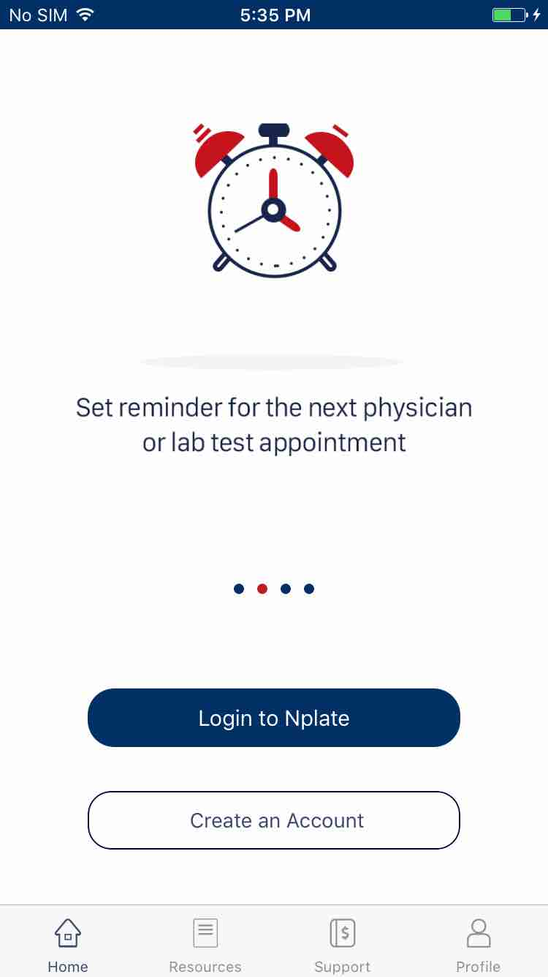

Regression.US_FullFlow_15-Nov-2017 07-30-32 PM.png

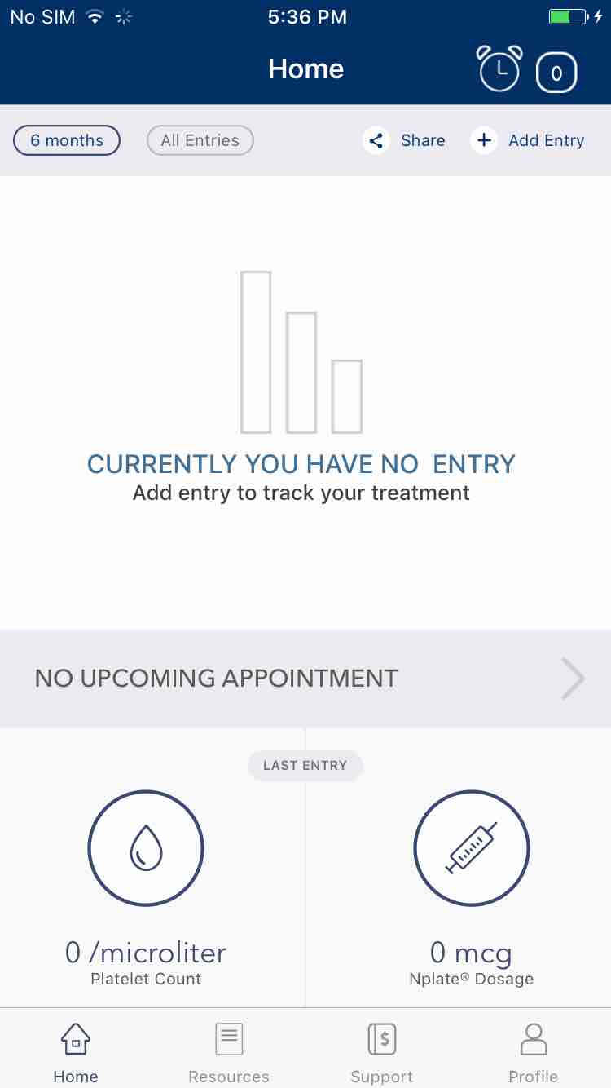

Regression.US_FullFlow_15-Nov-2017 07-31-07 PM.png

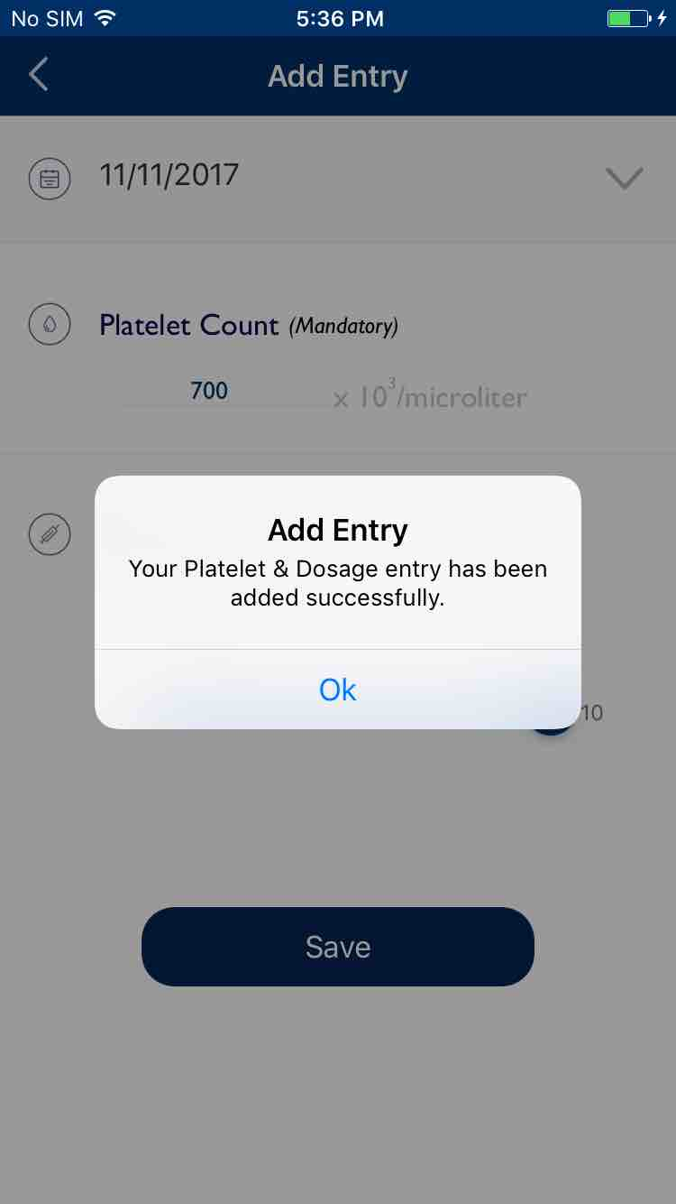

Regression.US_FullFlow_15-Nov-2017 07-32-00 PM.png

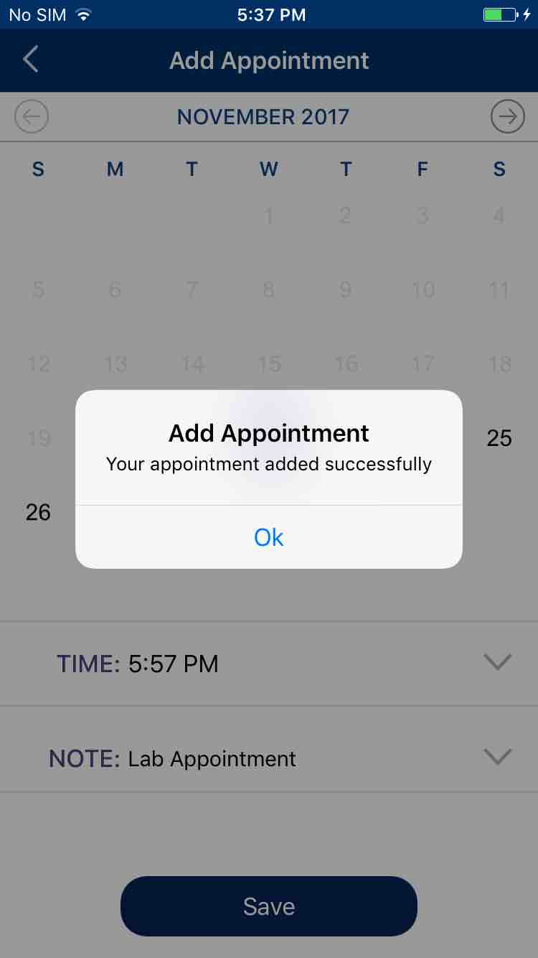

Regression.US_FullFlow_15-Nov-2017 07-32-21 PM.png

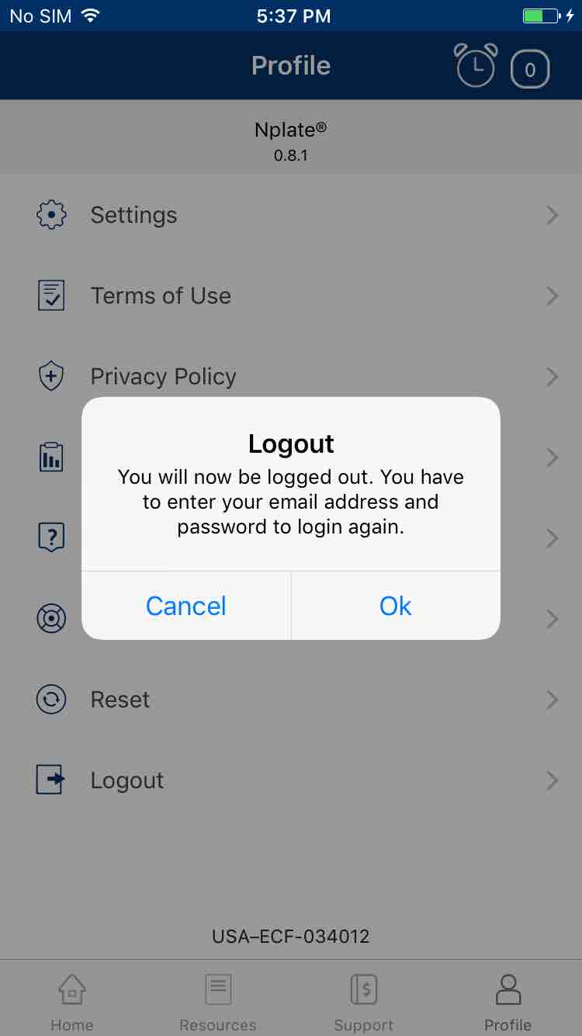

Regression.US_FullFlow_15-Nov-2017 07-32-42 PM.png

